Stability Analysis at plant Input and Output
Chris Bonney (April 2021)
Program Start 1
Plant Data 1
Dynamics without actuator 2
Dynamics with Actuator 2
Design RSLQR Controllers From HW3 2
Define RSLQG Parameters 2
Design RSLQG Controllers 3
Print Results 4
print controller info for vee = 10^-3 17

Program Start
clear all
close all
clc
format short e
% add my set of functions to path
addpath('functions')
RSLQR.name = 'RSLQR';

Plant Data
Controller Constants
Ka=-0.0015;
Kq=-0.32;
az=2;
aq=6;
% Dynamics Constants
V=886.78;
Za=-1.3046*V;
Zd=-0.2142*V;
Ma=47.7109;
Md=-104.8346;
% Actuator Constants
% omega = sqrt(12769);
% zeta = 0.6;
omega = 2.*pi*11;
zeta = sqrt(1/2);

Dynamics without actuator
Ap = [Za/V 1 ;
Ma 0 ];
Bp = [Zd/V ;
Md ];
Cp = [Za 0 ;
0 1 ];
Dp = [Zd ;
0 ];
RSLQR.DesignPlant = ss(Ap,Bp,Cp,Dp);
% Size of the plant model
[nx,~]=size(Ap);

Dynamics with Actuator
A_actuator = [0 1; -omega^2 -2*zeta*omega];
B_actuator = [0; omega^2];
Plant.Ap = [ Ap Bp zeros(2,1);
zeros(2,2) A_actuator];
Plant.Bp = [zeros(2,1); B_actuator];
Plant.Cp = [Za 0 Zd 0;
eye(4)];
% Plant.Cp = [Za 0 Zd 0;
% 1 0 0 0;
% 0 1 0 0];
Plant.Dp = 0*(Plant.Cp*Plant.Bp);
Ap = Plant.Ap;
Bp = Plant.Bp;
Cp = Plant.Cp;
Dp = Plant.Dp;
RSLQR.AnalysisPlant = ss(Ap,Bp,Cp,Dp);

Design RSLQR Controllers From HW3
RSLQR = design_lqr(RSLQR.DesignPlant,1,[2,3],RSLQR.AnalysisPlant,logspace(-6,-3,50),RSLQR);

Define RSLQG Parameters
Q0 = diag([ 0.001 0.0014 0.005 ]);
R0 = 1000*diag([ 0.025^2 0.001^2]);
c0 = 0.00001;
% c0 = 0.01;
vee = logspace(2,-3,3);
% vee = logspace(5,-5,3);
Aw = RSLQR.Aw;
Bw = RSLQR.Bw;
Kx = RSLQR.Kx;
Cw = [1 0 0;
0 0 1];
Dw = [0;0];
Aw_lqg = Aw;
Bw_lqg = Bw;
Cw_lqg = Cw;
Dw_lqg = Dw;
sys_1 = ss(Aw_lqg, Bw_lqg, Cw_lqg, Dw_lqg);
zz = [-10];
sys_2 = square_system_inputs_pp(sys_1,zz);
disp(['BbarMatrix z = ' num2str(zz) ])
sys_2.b
tzero(sys_2)
for ii=1:length(vee)
RSLQG(ii) = RSLQR;
end
BbarMatrix z = -10
ans =
-1.8995e+02 4.8314e-01
-2.1420e-01 -1.6098e-02
-1.0483e+02 -8.7539e-01
ans =
-1.0000e+01

Design RSLQG Controllers
for ii=1:length(vee)
RSLQG(ii).name = strcat('RSLQG, vee = ', num2str(vee(ii)));
Qv = Q0 + c0*(vee(ii)+1)/vee(ii)*(sys_2.b*sys_2.b');
Rv = (vee(ii)/(vee(ii)+1))*R0;
RSLQG(ii).Qv = Qv;
RSLQG(ii).Rv = Rv;
Lvee = lqr(Aw',Cw',Qv,R0)';
RSLQG(ii).Lvee = Lvee;
RSLQG(ii).Controller.Ac = [0 zeros(1,3); Lvee(:,1) Aw - Bw*Kx - Lvee*Cw];
RSLQG(ii).Controller.Bc1 = [ 1 0 0 0 0; zeros(3,2) Lvee(:,2) zeros(3,2)];
RSLQG(ii).Controller.Bc2 = [-1;-1; 0; 0];
RSLQG(ii).Controller.Cc = [0 -Kx];
RSLQG(ii).Controller.Dc1 = [0 0 0 0 0];
RSLQG(ii).Controller.Dc2 = [0];
RSLQG(ii) = design_metrics(RSLQG(ii).AnalysisPlant,RSLQG(ii).Controller,RSLQG(ii));
end

Print Results
print_analysis(RSLQR,RSLQG(1),RSLQG(2),RSLQG(3))
% print_analysis(RSLQR,RSLQG)
RSLQR Controller Model
[ Ac Bc1 Bc1 ]
HH =
[ 0, 1.0, 0, 0, 0, 0, -1.0]
[ Cc Dc1 Dc2 ]
HH =
[ -0.00954, 0, 2.63, 0.238, 0, 0, 0]
RSLQG, vee =100 Controller Model
[ Ac Bc1 Bc1 ]
HH =
[ 0, 0, 0, 0, 1.0, 0, 0, 0, 0, -1.0]
[ 9.21, -7.39, -1660.0, 73.2, 0, 0, -118.0, 0, 0, -1.0]
[ -0.0461, 0.0481, -1.87, -0.556, 0, 0, 1.5, 0, 0, 0]
[ -0.189, 1.19, -228.0, -40.4, 0, 0, 15.4, 0, 0, 0]
[ Cc Dc1 Dc2 ]
HH =
[ 0, -0.00954, 2.63, 0.238, 0, 0, 0, 0, 0, 0]
RSLQG, vee =0.31623 Controller Model
[ Ac Bc1 Bc1 ]
HH =
[ 0, 0, 0, 0, 1.0, 0, 0, 0, 0, -1.0]
[ 10.2, -8.37, -1660.0, 19.9, 0, 0, -65.1, 0, 0, -1.0]
[ -0.0467, 0.0488, -1.87, -0.508, 0, 0, 1.46, 0, 0, 0]
[ -0.104, 1.1, -228.0, -49.3, 0, 0, 24.4, 0, 0, 0]
[ Cc Dc1 Dc2 ]
HH =
[ 0, -0.00954, 2.63, 0.238, 0, 0, 0, 0, 0, 0]
RSLQG, vee =0.001 Controller Model
[ Ac Bc1 Bc1 ]
HH =
[ 0, 0, 0, 0, 1.0, 0, 0, 0, 0, -1.0]
[ 13.0, -11.2, -1660.0, -614.0, 0, 0, 569.0, 0, 0, -1.0]
[ -0.047, 0.0491, -1.87, -0.85, 0, 0, 1.8, 0, 0, 0]
[ 0.91, 0.0898, -228.0, -356.0, 0, 0, 331.0, 0, 0, 0]
[ Cc Dc1 Dc2 ]
HH =
[ 0, -0.00954, 2.63, 0.238, 0, 0, 0, 0, 0, 0]
RSLQR Closed Loop Eigenvectors
V =
Columns 1 through 2
1.0786e-03 - 5.3831e-04i 1.0786e-03 + 5.3831e-04i
-8.6197e-03 + 5.3792e-02i -8.6197e-03 - 5.3792e-02i
1.4975e-02 + 1.7154e-02i 1.4975e-02 - 1.7154e-02i
-9.9198e-01 + 0.0000e+00i -9.9198e-01 + 0.0000e+00i
1.6200e-02 + 1.1055e-01i 1.6200e-02 - 1.1055e-01i
Columns 3 through 4
-9.2478e-03 + 0.0000e+00i 6.3990e-03 - 6.9127e-03i
2.1023e-01 + 0.0000e+00i -1.2874e-03 + 1.0138e-01i
4.2040e-02 + 0.0000e+00i 9.5275e-03 + 5.9743e-03i
-9.6959e-01 + 0.0000e+00i -1.3059e-01 + 1.0489e-02i
-1.1764e-01 + 0.0000e+00i 9.8607e-01 + 0.0000e+00i
Column 5
6.3990e-03 + 6.9127e-03i
-1.2874e-03 - 1.0138e-01i
9.5275e-03 - 5.9743e-03i
-1.3059e-01 - 1.0489e-02i
9.8607e-01 + 0.0000e+00i
RSLQR Closed Loop Eigenvalues
ans =
-2.8650e+01 + 3.2818e+01i
-2.8650e+01 - 3.2818e+01i
-2.3063e+01 + 0.0000e+00i
-9.3428e+00 + 6.9594e+00i
-9.3428e+00 - 6.9594e+00i
RSLQG, vee =100 Closed Loop Eigenvectors
V =
Columns 1 through 2
-1.1781e-04 + 1.8425e-04i -1.1781e-04 - 1.8425e-04i
-4.0515e-03 - 1.7943e-02i -4.0515e-03 + 1.7943e-02i
-1.0368e-02 - 8.2247e-03i -1.0368e-02 + 8.2247e-03i
9.9892e-01 + 0.0000e+00i 9.9892e-01 + 0.0000e+00i
-1.0747e-02 - 3.1340e-02i -1.0747e-02 + 3.1340e-02i
1.1843e-02 - 1.8698e-02i 1.1843e-02 + 1.8698e-02i
-2.2491e-04 + 3.0268e-04i -2.2491e-04 - 3.0268e-04i
-6.6797e-03 + 2.5679e-03i -6.6797e-03 - 2.5679e-03i
Columns 3 through 4
-2.4672e-03 - 5.7185e-03i -2.4672e-03 + 5.7185e-03i
1.0765e-01 - 3.1860e-02i 1.0765e-01 + 3.1860e-02i
-2.1994e-03 - 2.2015e-02i -2.1994e-03 + 2.2015e-02i
3.9815e-01 + 5.3172e-02i 3.9815e-01 - 5.3172e-02i
5.3726e-01 - 3.1232e-01i 5.3726e-01 + 3.1232e-01i
6.5820e-01 + 0.0000e+00i 6.5820e-01 + 0.0000e+00i
-2.5680e-03 - 6.7899e-03i -2.5680e-03 + 6.7899e-03i
7.7400e-02 - 6.9912e-03i 7.7400e-02 + 6.9912e-03i
Columns 5 through 6
-2.3303e-03 + 3.7967e-03i -2.3303e-03 - 3.7967e-03i
-1.6980e-02 - 2.5367e-02i -1.6980e-02 + 2.5367e-02i
-3.2442e-03 + 1.6779e-03i -3.2442e-03 - 1.6779e-03i
3.7002e-03 - 2.7147e-02i 3.7002e-03 + 2.7147e-02i
-7.6771e-01 + 0.0000e+00i -7.6771e-01 + 0.0000e+00i
-6.3291e-01 + 8.6738e-02i -6.3291e-01 - 8.6738e-02i
-2.1906e-03 + 2.9345e-03i -2.1906e-03 - 2.9345e-03i
-1.4368e-02 - 2.4065e-02i -1.4368e-02 + 2.4065e-02i
Columns 7 through 8
4.0256e-03 - 8.4318e-04i 4.0256e-03 + 8.4318e-04i
-2.0563e-02 + 9.6570e-03i -2.0563e-02 - 9.6570e-03i
6.3106e-04 + 4.7766e-04i 6.3106e-04 - 4.7766e-04i
-4.8254e-03 - 2.4195e-03i -4.8254e-03 + 2.4195e-03i
7.1232e-01 + 0.0000e+00i 7.1232e-01 + 0.0000e+00i
7.0109e-01 + 7.5601e-03i 7.0109e-01 - 7.5601e-03i
4.3607e-03 - 7.5711e-04i 4.3607e-03 + 7.5711e-04i
-1.7753e-02 + 1.0464e-02i -1.7753e-02 - 1.0464e-02i
RSLQG, vee =100 Closed Loop Eigenvalues
ans =
-5.9135e+01 + 4.6910e+01i
-5.9135e+01 - 4.6910e+01i
-4.1802e+00 + 1.7667e+01i
-4.1802e+00 - 1.7667e+01i
-4.3143e+00 + 6.1365e+00i
-4.3143e+00 - 6.1365e+00i
-6.7064e+00 + 1.2420e+00i
-6.7064e+00 - 1.2420e+00i
RSLQG, vee =0.31623 Closed Loop Eigenvectors
V =
Columns 1 through 2
-9.7285e-05 + 1.8392e-04i -9.7285e-05 - 1.8392e-04i
-4.8603e-03 - 1.7184e-02i -4.8603e-03 + 1.7184e-02i
-1.0427e-02 - 7.8282e-03i -1.0427e-02 + 7.8282e-03i
9.9916e-01 + 0.0000e+00i 9.9916e-01 + 0.0000e+00i
-1.1860e-02 - 2.9696e-02i -1.1860e-02 + 2.9696e-02i
3.9897e-04 - 7.5937e-03i 3.9897e-04 + 7.5937e-03i
-1.9521e-04 + 2.8766e-04i -1.9521e-04 - 2.8766e-04i
-9.5927e-03 + 4.0622e-03i -9.5927e-03 - 4.0622e-03i
Columns 3 through 4
8.1894e-04 - 6.6137e-03i 8.1894e-04 + 6.6137e-03i
1.2180e-01 + 3.6375e-02i 1.2180e-01 - 3.6375e-02i
1.2886e-02 - 2.2668e-02i 1.2886e-02 + 2.2668e-02i
3.5142e-01 + 3.5723e-01i 3.5142e-01 - 3.5723e-01i
6.4676e-01 + 0.0000e+00i 6.4676e-01 + 0.0000e+00i
5.2125e-01 + 1.8495e-01i 5.2125e-01 - 1.8495e-01i
1.2766e-03 - 7.2721e-03i 1.2766e-03 + 7.2721e-03i
8.3697e-02 + 2.7206e-02i 8.3697e-02 - 2.7206e-02i
Columns 5 through 6
-2.6160e-03 + 3.9204e-03i -2.6160e-03 - 3.9204e-03i
-1.6251e-02 - 3.1703e-02i -1.6251e-02 + 3.1703e-02i
-3.9469e-03 + 1.2373e-03i -3.9469e-03 - 1.2373e-03i
1.2234e-02 - 3.1941e-02i 1.2234e-02 + 3.1941e-02i
-7.3576e-01 + 0.0000e+00i -7.3576e-01 + 0.0000e+00i
-6.6630e-01 + 1.0525e-01i -6.6630e-01 - 1.0525e-01i
-2.3630e-03 + 3.2954e-03i -2.3630e-03 - 3.2954e-03i
-1.6027e-02 - 2.9476e-02i -1.6027e-02 + 2.9476e-02i
Columns 7 through 8
4.5493e-03 - 1.9754e-03i 4.5493e-03 + 1.9754e-03i
-2.3166e-02 + 2.5533e-02i -2.3166e-02 - 2.5533e-02i
1.0564e-03 + 1.5798e-03i 1.0564e-03 - 1.5798e-03i
-1.2479e-02 - 9.1538e-03i -1.2479e-02 + 9.1538e-03i
7.1383e-01 + 0.0000e+00i 7.1383e-01 + 0.0000e+00i
6.9839e-01 + 7.0536e-03i 6.9839e-01 - 7.0536e-03i
4.7577e-03 - 1.8596e-03i 4.7577e-03 + 1.8596e-03i
-2.1036e-02 + 2.6680e-02i -2.1036e-02 - 2.6680e-02i
RSLQG, vee =0.31623 Closed Loop Eigenvalues
ans =
-6.1283e+01 + 4.6009e+01i
-6.1283e+01 - 4.6009e+01i
-5.2494e+00 + 1.8487e+01i
-5.2494e+00 - 1.8487e+01i
-5.1323e+00 + 6.4838e+00i
-5.1323e+00 - 6.4838e+00i
-7.6541e+00 + 2.7811e+00i
-7.6541e+00 - 2.7811e+00i
RSLQG, vee =0.001 Closed Loop Eigenvectors
V =
Columns 1 through 2
5.7162e-07 + 0.0000e+00i -1.6942e-03 + 1.0664e-03i
-7.3866e-04 + 0.0000e+00i 7.7178e-03 - 7.4738e-02i
-2.5036e-03 + 0.0000e+00i -1.8014e-02 - 1.9298e-02i
8.8968e-01 + 0.0000e+00i 9.6665e-01 + 0.0000e+00i
-1.3364e-03 + 0.0000e+00i -5.1743e-02 - 1.5276e-01i
-3.9855e-01 + 0.0000e+00i -6.0558e-02 - 1.5411e-01i
-4.7686e-04 + 0.0000e+00i -1.7064e-03 + 1.0570e-03i
-2.2274e-01 + 0.0000e+00i 2.5785e-03 - 7.6141e-02i
Columns 3 through 4
-1.6942e-03 - 1.0664e-03i -3.2899e-03 + 3.7959e-03i
7.7178e-03 + 7.4738e-02i -7.0712e-03 - 3.9146e-02i
-1.8014e-02 + 1.9298e-02i -4.1778e-03 - 2.4846e-04i
9.6665e-01 + 0.0000e+00i 2.8153e-02 - 2.3591e-02i
-5.1743e-02 + 1.5276e-01i -7.2089e-01 + 0.0000e+00i
-6.0558e-02 + 1.5411e-01i -6.8831e-01 + 4.4227e-02i
-1.7064e-03 - 1.0570e-03i -3.2092e-03 + 3.4589e-03i
2.5785e-03 + 7.6141e-02i -7.3347e-03 - 3.9180e-02i
Columns 5 through 6
-3.2899e-03 - 3.7959e-03i 4.7270e-03 - 4.7366e-03i
-7.0712e-03 + 3.9146e-02i -6.0021e-03 + 7.0635e-02i
-4.1778e-03 + 2.4846e-04i 6.0447e-03 + 4.5832e-03i
2.8153e-02 + 2.3591e-02i -8.7238e-02 - 3.4974e-03i
-7.2089e-01 + 0.0000e+00i 7.0064e-01 + 1.6955e-04i
-6.8831e-01 - 4.4227e-02i 7.0092e-01 + 0.0000e+00i
-3.2092e-03 - 3.4589e-03i 4.7311e-03 - 4.7322e-03i
-7.3347e-03 + 3.9180e-02i -5.4773e-03 + 7.0686e-02i
Columns 7 through 8
4.7270e-03 + 4.7366e-03i 3.4741e-03 + 0.0000e+00i
-6.0021e-03 - 7.0635e-02i -1.1076e-01 + 0.0000e+00i
6.0447e-03 - 4.5832e-03i -3.1431e-02 + 0.0000e+00i
-8.7238e-02 + 3.4974e-03i 9.8215e-01 + 0.0000e+00i
7.0064e-01 - 1.6955e-04i -6.2444e-02 + 0.0000e+00i
7.0092e-01 + 0.0000e+00i -6.9679e-02 + 0.0000e+00i
4.7311e-03 + 4.7322e-03i 3.4562e-03 + 0.0000e+00i
-5.4773e-03 - 7.0686e-02i -1.1552e-01 + 0.0000e+00i
RSLQG, vee =0.001 Closed Loop Eigenvalues
ans =
-3.5536e+02 + 0.0000e+00i
-2.4986e+01 + 2.6767e+01i
-2.4986e+01 - 2.6767e+01i
-6.3804e+00 + 6.0262e+00i
-6.3804e+00 - 6.0262e+00i
-9.4424e+00 + 6.5808e+00i
-9.4424e+00 - 6.5808e+00i
-3.1247e+01 + 0.0000e+00i
RSLQR Classical Margins
GainMargin: [3.4428e-01 3.1892e+00]
GMFrequency: [7.6743e+00 6.0081e+01]
PhaseMargin: 3.2804e+01
PMFrequency: 2.3002e+01
DelayMargin: 2.4891e-02
DMFrequency: 2.3002e+01
Stable: 1
RSLQG, vee =100 Classical Margins
GainMargin: [2.9359e-01 1.8696e+00]
GMFrequency: [4.6346e+00 2.9333e+01]
PhaseMargin: 1.3195e+01
PMFrequency: 1.7452e+01
DelayMargin: 1.3196e-02
DMFrequency: 1.7452e+01
Stable: 1
RSLQG, vee =0.31623 Classical Margins
GainMargin: [4.0349e-01 1.9092e+00]
GMFrequency: [7.5159e+00 3.1361e+01]
PhaseMargin: 1.4937e+01
PMFrequency: 1.8092e+01
DelayMargin: 1.4410e-02
DMFrequency: 1.8092e+01
Stable: 1
RSLQG, vee =0.001 Classical Margins
GainMargin: [3.6042e-01 2.7059e+00]
GMFrequency: [7.7025e+00 5.2805e+01]
PhaseMargin: 2.9626e+01
PMFrequency: 2.2209e+01
DelayMargin: 2.3282e-02
DMFrequency: 2.2209e+01
Stable: 1
RSLQR Combined SV Margins
Min SV of RD: min(I+Lu) = 0.51112
Min SV of SR: min(I+Lu) = 0.51384
Singular Value GM = [-6.2645 dB , 6.216 dB]
Singular Value PM = [+/-29.7749 deg]
RSLQG, vee =100 Combined SV Margins
Min SV of RD: min(I+Lu) = 0.22322
Min SV of SR: min(I+Lu) = 0.22996
Singular Value GM = [-2.2698 dB , 2.194 dB]
Singular Value PM = [+/-13.2051 deg]
RSLQG, vee =0.31623 Combined SV Margins
Min SV of RD: min(I+Lu) = 0.25
Min SV of SR: min(I+Lu) = 0.25993
Singular Value GM = [-2.6146 dB , 2.4988 dB]
Singular Value PM = [+/-14.9352 deg]
RSLQG, vee =0.001 Combined SV Margins
Min SV of RD: min(I+Lu) = 0.46554
Min SV of SR: min(I+Lu) = 0.48214
Singular Value GM = [-5.7157 dB , 5.4417 dB]
Singular Value PM = [+/-27.8991 deg]
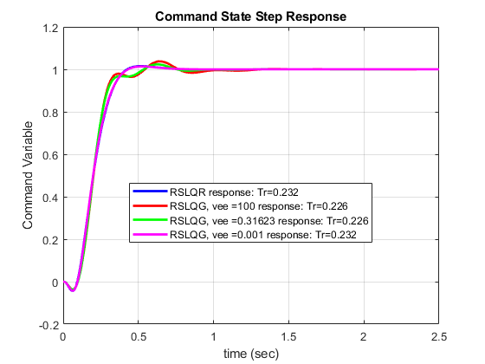
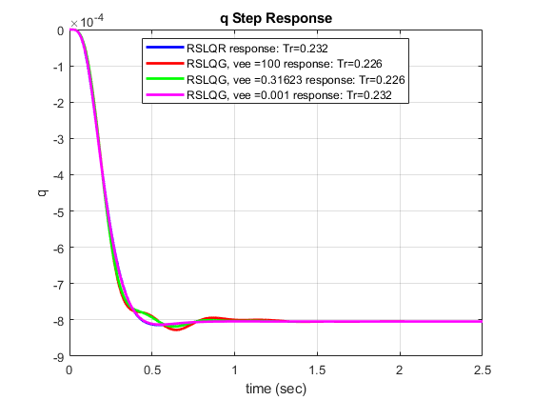
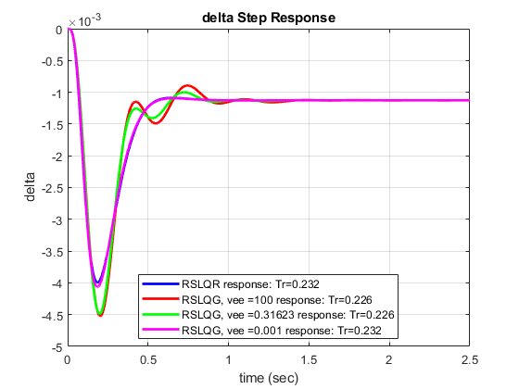
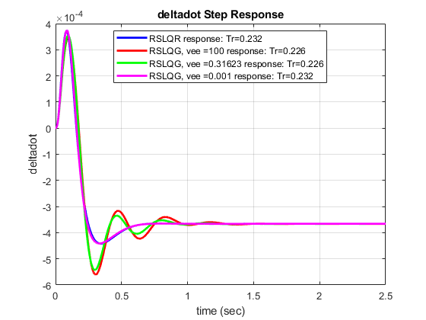
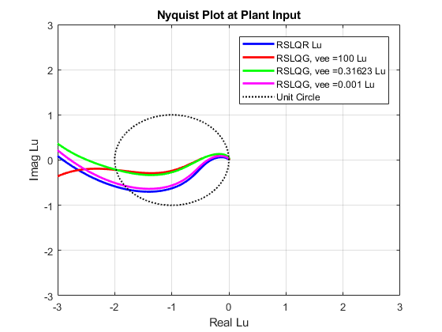
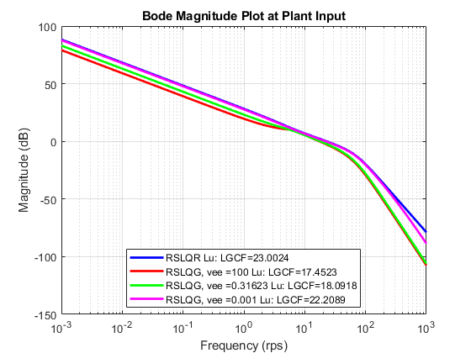
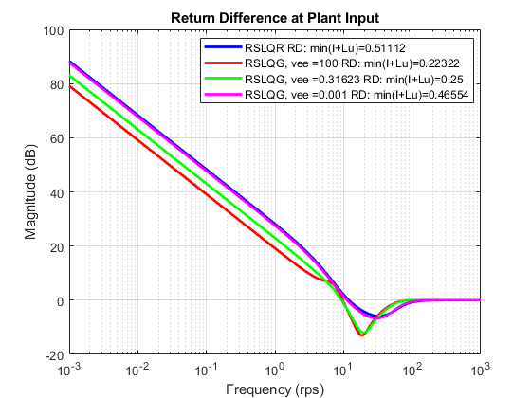
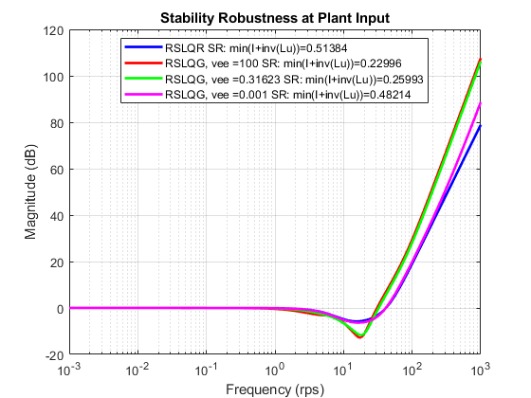
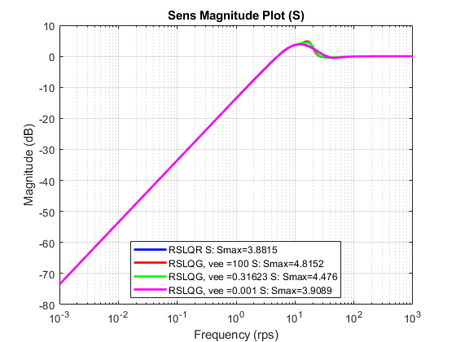
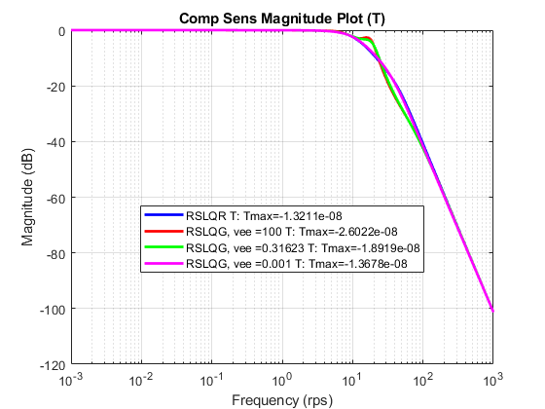
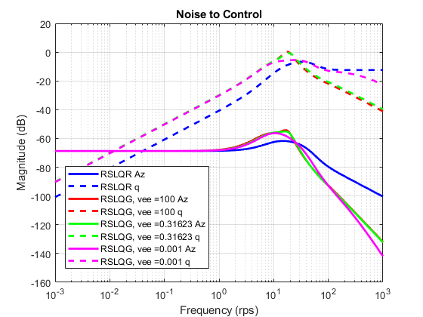
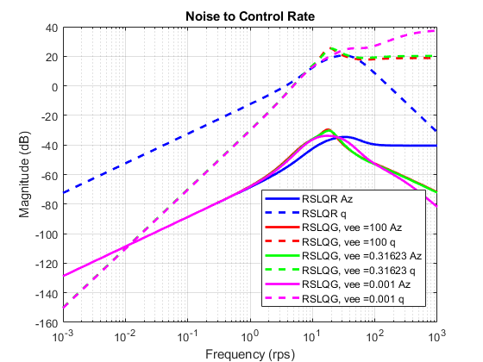

print controller info for vee = 10^-3
Aw = RSLQG(3).Aw
C = RSLQG(3).AnalysisPlant.C
Q = RSLQG(3).Qv
R = RSLQG(3).Rv
Lvee = RSLQG(3).Lvee
Ac = RSLQG(3).Controller.Ac
Bc1 = RSLQG(3).Controller.Bc1
Bc2 = RSLQG(3).Controller.Bc2
Cc = RSLQG(3).Controller.Cc
Dc1 = RSLQG(3).Controller.Dc1
Dc2 = RSLQG(3).Controller.Dc2
Aw =
0 -1.1569e+03 0
0 -1.3046e+00 1.0000e+00
0 4.7711e+01 0
C =
-1.1569e+03 0 -1.8995e+02 0
1.0000e+00 0 0 0
0 1.0000e+00 0 0
0 0 1.0000e+00 0
0 0 0 1.0000e+00
Q =
3.6117e+02 4.0720e-01 1.9933e+02
4.0720e-01 1.8619e-03 2.2492e-01
1.9933e+02 2.2492e-01 1.1003e+02
R =
6.2438e-04 0
0 9.9900e-07
Lvee =
1.2985e+01 5.6904e+02
-4.7039e-02 1.7993e+00
9.1046e-01 3.3118e+02
Ac =
0 0 0 0
1.2985e+01 -1.1173e+01 -1.6559e+03 -6.1426e+02
-4.7039e-02 4.9083e-02 -1.8673e+00 -8.5028e-01
9.1046e-01 8.9762e-02 -2.2769e+02 -3.5614e+02
Bc1 =
1.0000e+00 0 0 0 0
0 0 5.6904e+02 0 0
0 0 1.7993e+00 0 0
0 0 3.3118e+02 0 0
Bc2 =
-1
-1
0
0
Cc =
0 -9.5410e-03 2.6270e+00 2.3809e-01
Dc1 =
0 0 0 0 0
Dc2 =
0
save('RSLQG_design.mat','RSLQG');
Published with MATLAB® R2020a

